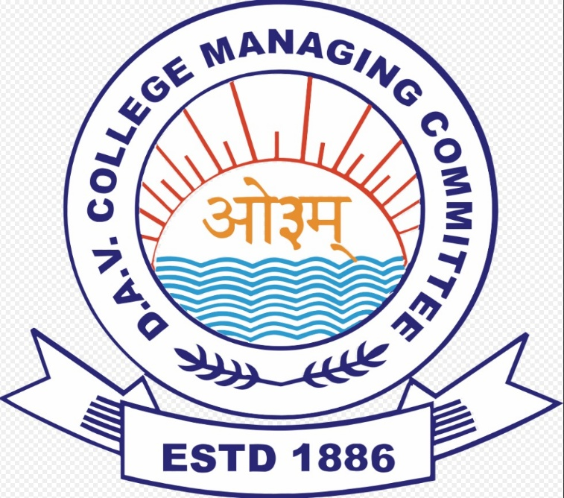
CBT FORM VERIFICATION CENTRE
FOR DAV CBT – JANUARY 2026
From November 01 to 26, 2025

